Number of Responses: 413

Patient Survey 2023
Q1. Generally, how easy is it to get through to this GP practice on the telephone?
Very easy: 29%
Fairly easy: 52%
Not very easy: 12%
Not easy at all: 4%
No response: 3%
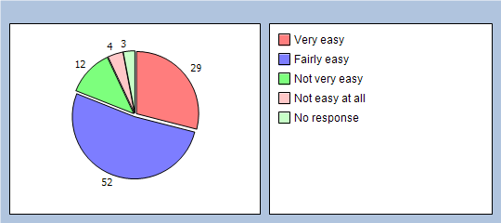

Q2. How easy is it to use this GP practice's website to look for information or access services?
Very easy: 22%
Fairly easy: 17%
Not very easy: 2%
Not easy at all: 1%
I haven't used the website, but I'm aware of it: 30%
I'm not aware of it: 20%
No response: 8%
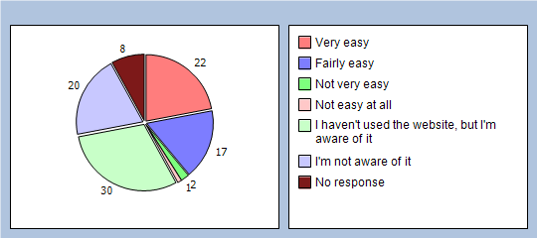

Q3. Overall, how would you describe your experience of the online triage service available on our website?
Very good: 25%
Good: 19%
Neither good nor poor: 3%
Poor: 0%
Very poor: 0%
I haven’t used the triage service, but I'm aware of it: 27%
I'm not aware of the triage service: 20%
No response: 6%
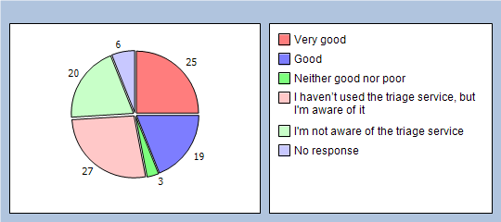

Q4. Were you satisfied with the appointment (or appointments) you were offered?
Yes and I accepted an appointment: 85%
No, but I still took an appointment: 4%
No and I didn’t accept an appointment: 0%
I didn't need an appointment: 6%
No response: 5%
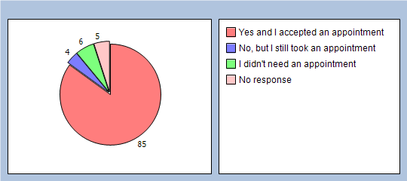

Q5. Overall, how would you describe your experience of making an appointment?
Very good: 42%
Good: 33%
Neither good not poor: 14%
Poor: 3%
Very poor: 1%
I didn't need an appointment: 3%
No response: 4%
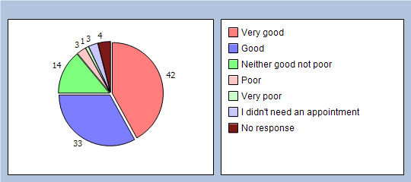

Q6. Overall, how would you describe your experience of this GP practice?
Very good: 57%
Good: 33%
Neither good not poor: 5%
Poor: 0%
Very poor: 1%
No response: 4%
